TECHNICAL -DAY-1
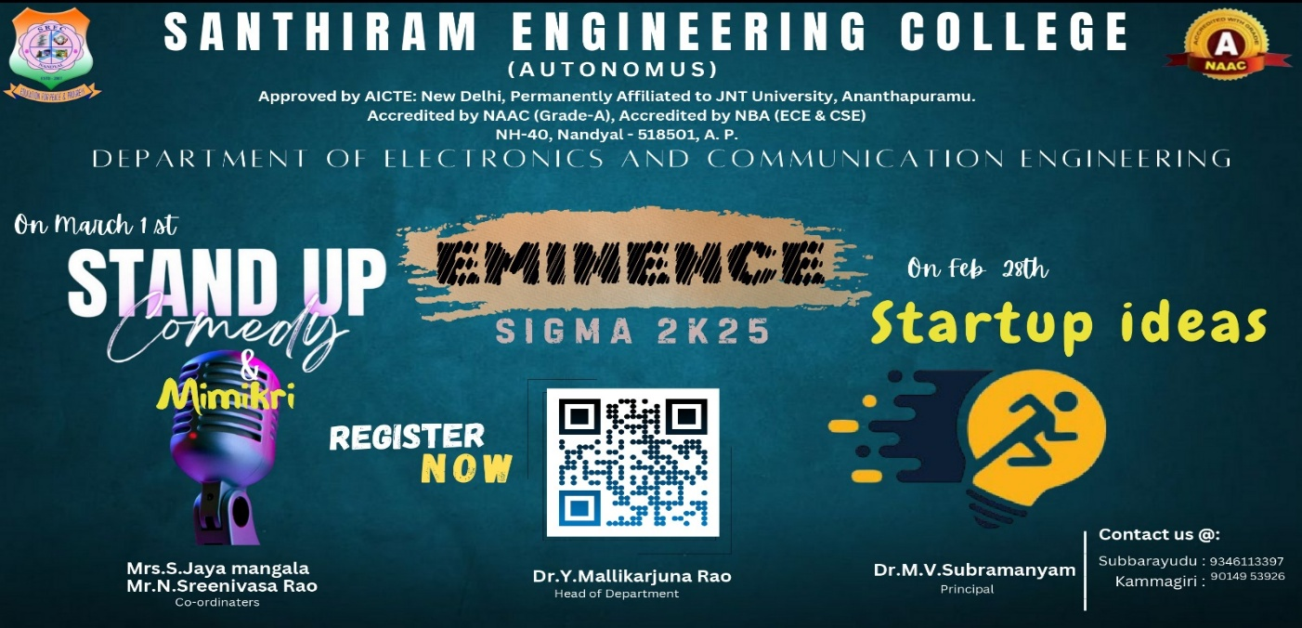
1.START UP IDEAS- https://shorturl.at/1jvD8
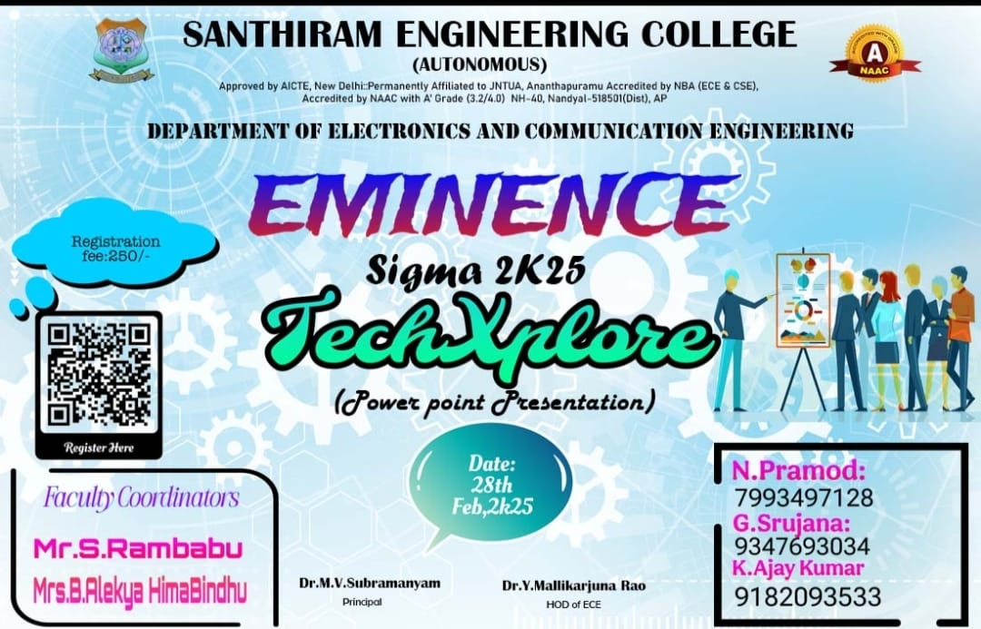
2. Tech Xplore -bit.ly/4jFzwAX
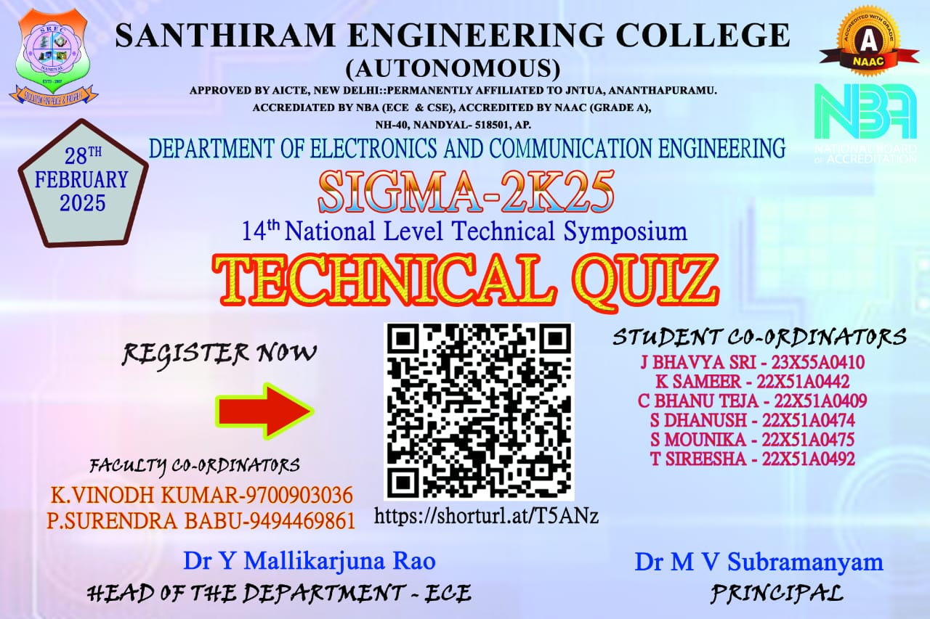
3. Technical quiz - https://shorturl.at/T5ANz

NONTECHNICAL -DAY-2

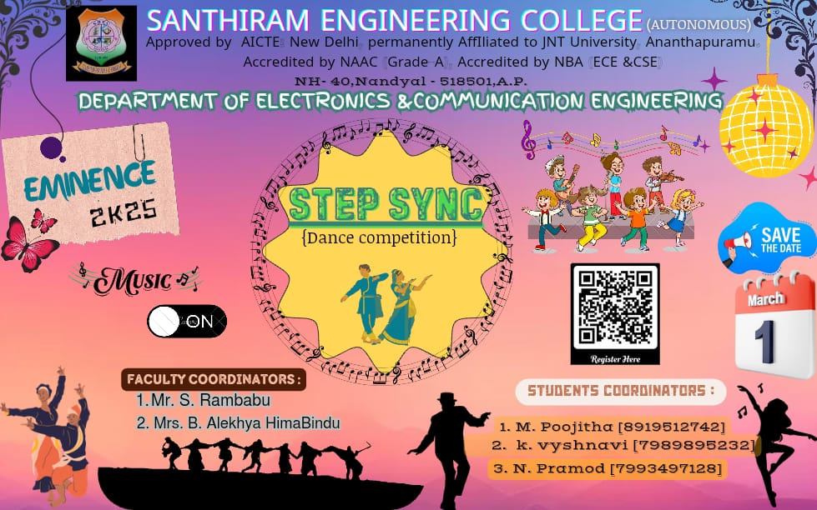
- Step Sync (Dance Competition) -bit.ly/4jFzwAX
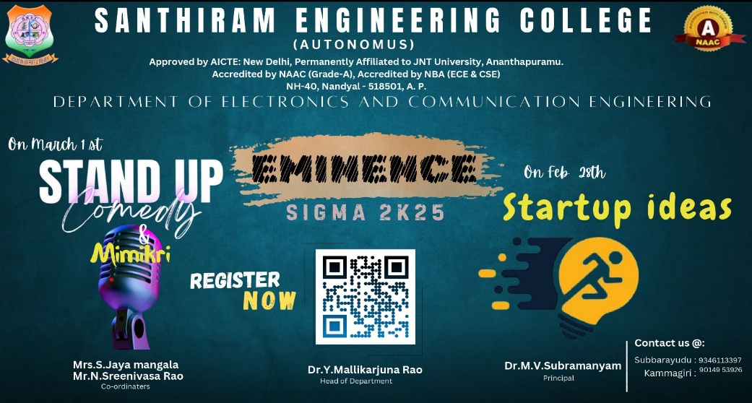
- Standup Comedy /Mimicry- https://shorturl.at/1jvD8
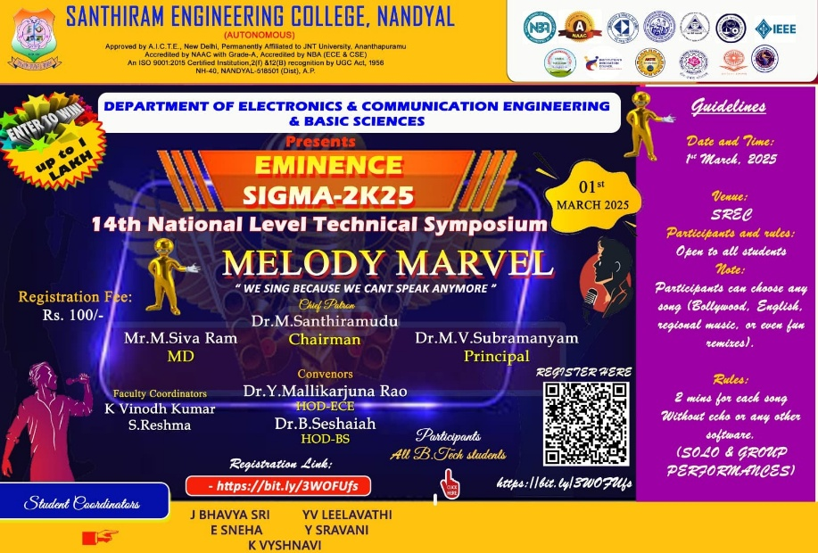
- Melody Marvel - https://bit.ly/3WOFUfs
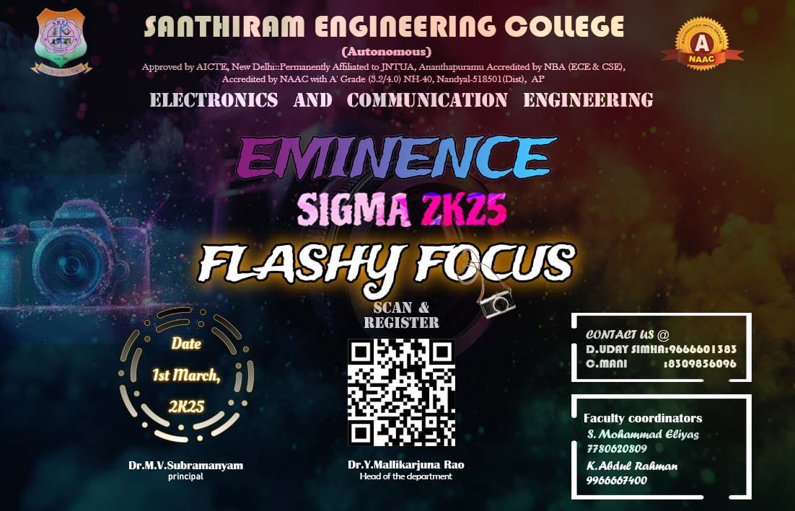
- Flashy focus - https://goto.now/TlHfA
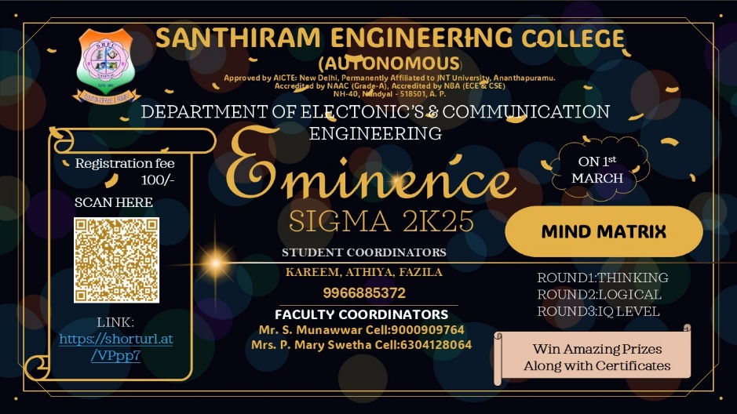
- Mind Matrix-https://shorturl.at/VPpp7
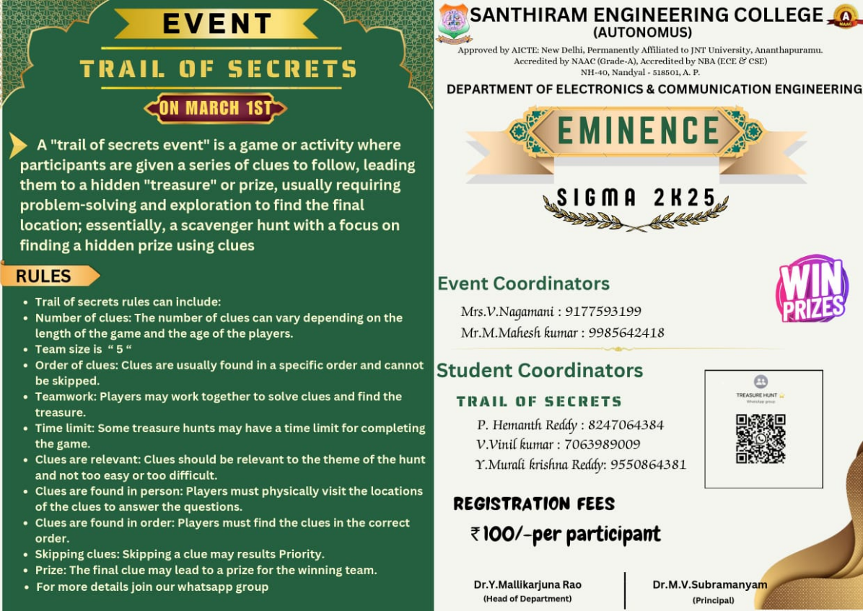
- Trails of Secrets- https://forms.gle/yYtpwgr7SFubCceX8
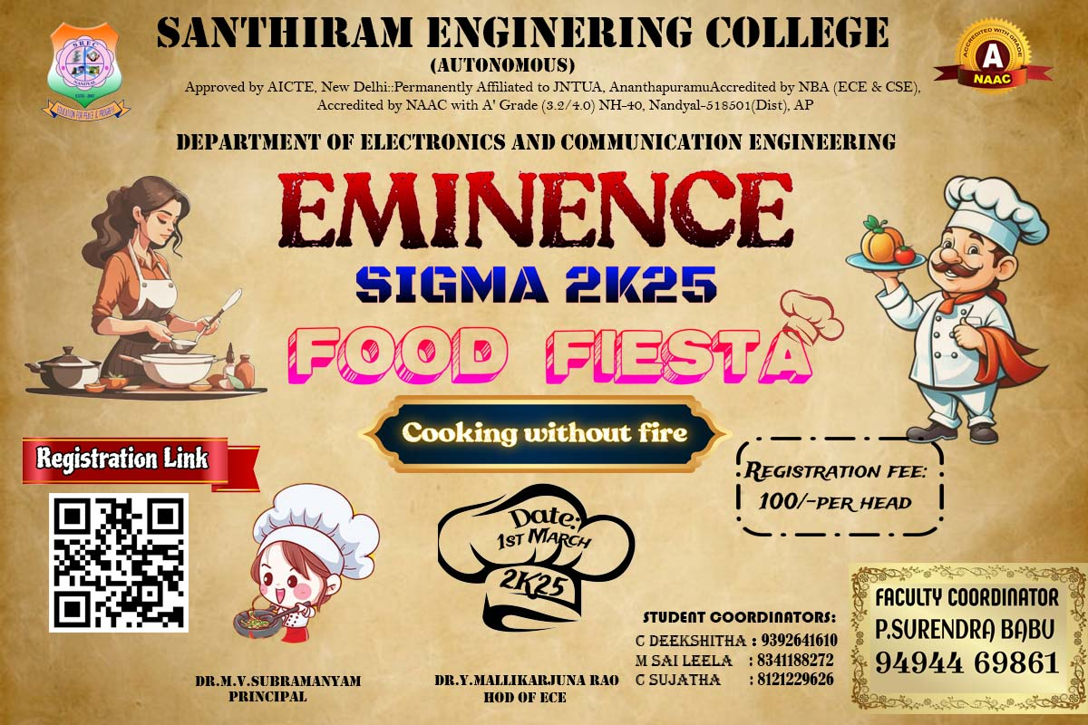

- Master Chef Challenge https://tinyurl.com/4wpus52t
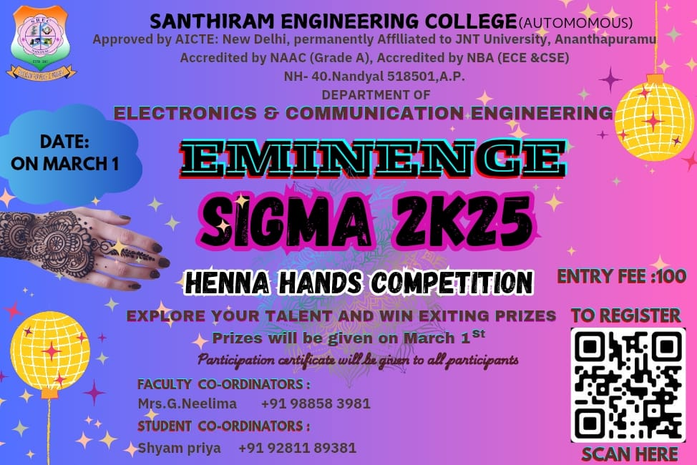
- Henna hands Challenge - https://bit.ly/3CGCEfd
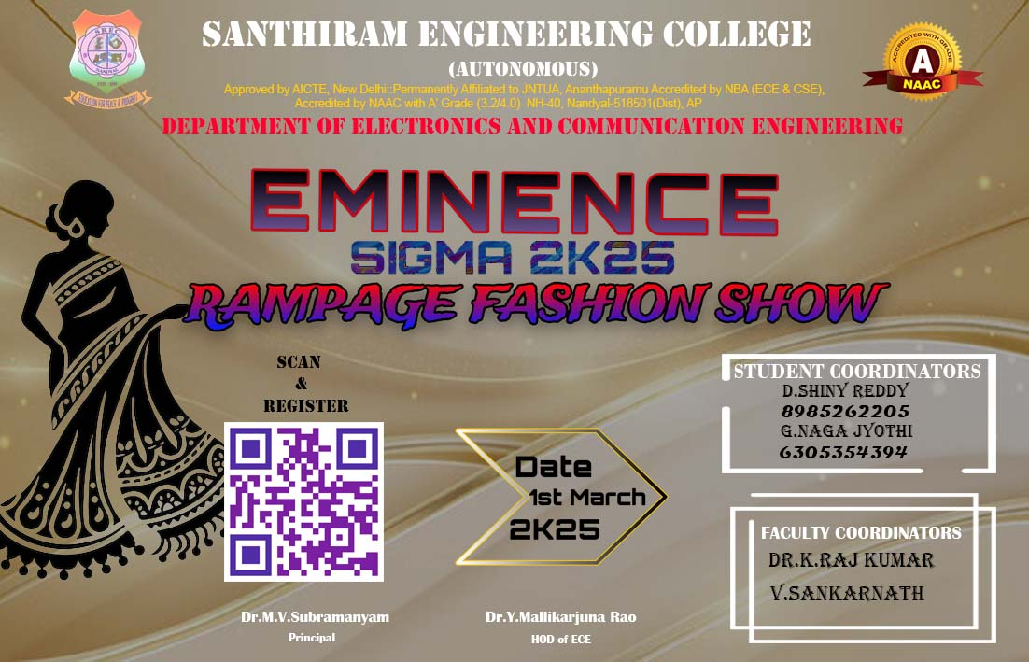

- Rampage Fashion Show https://tinyurl.com/yc2eux68

